P S P S’s
INDIRA INSTITUTE OF PHARMACY
A Report on Seminar “GENDER EQUALITY TODAY FOR SUSTAINABLE FUTURE” organized by Department of Lifelong Learning and Extension cell
Date: 30th March 2022

Department of Lifelong Learning and Extension (DLLE) cell of our PSPS’s Indira Institute of Pharmacy Sadavali, has arranged Seminar “GENDER EQUALITY TODAY FOR SUSTAINABLE FUTURE” on 30th March 2022.
This program has been organized by Online mode through google meet Platform by the following google meet link, http://meet.google.com/gyp-znve-yva.
Live program was hosted by Dr. Prashant Nargude, Assistant Professor, Department of Sociology at A. S. P. College Devrukh. He addressed the legal protections and how gender equality is linked to peace and good for the economy. Also he stressed on different ways by which we can promote gender equality in daily life by giving different suitable examples.
Welcome address was given by Dr. A. B. Khade, Principal of the Indira Institute of Pharmacy Sadavali. He e-felicitated the speaker and congratulated the students and coordinators of DLLE cell, Mrs. Ketaki Dhane and Ms. Salina Fernandes for this activity.
The DLLE Students (87) of PSPS’s Indira Institute of Pharmacy, Sadavali actively participated in this session. The meeting was concluded by proposing the vote of thanks by Ms. V. B. Nalawade.

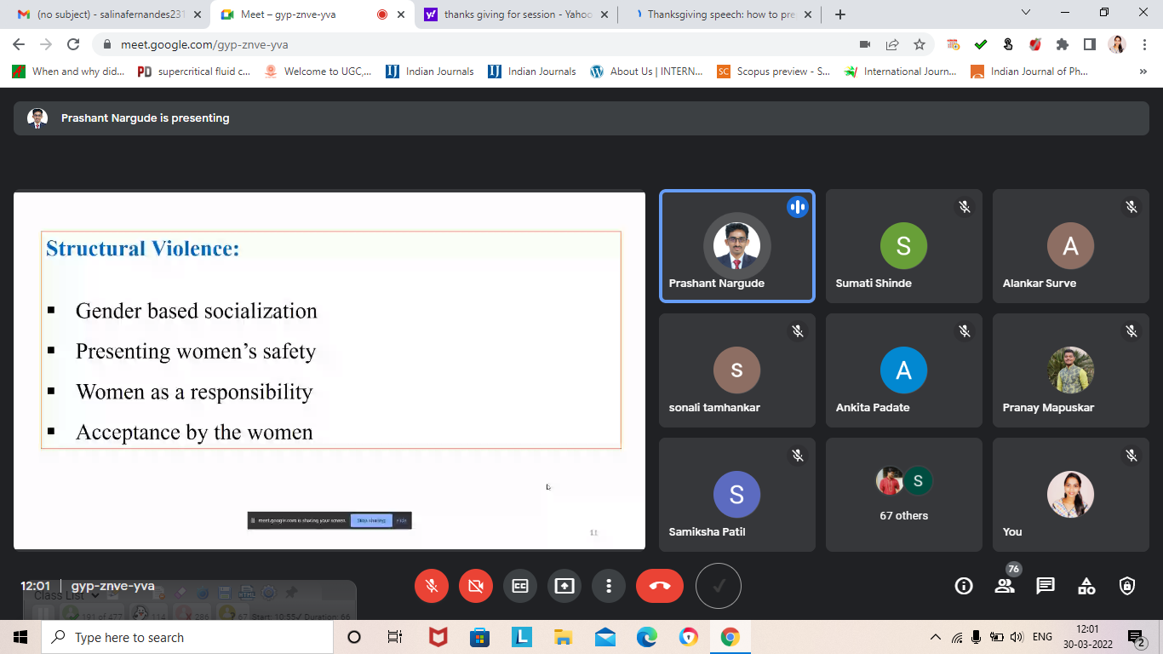
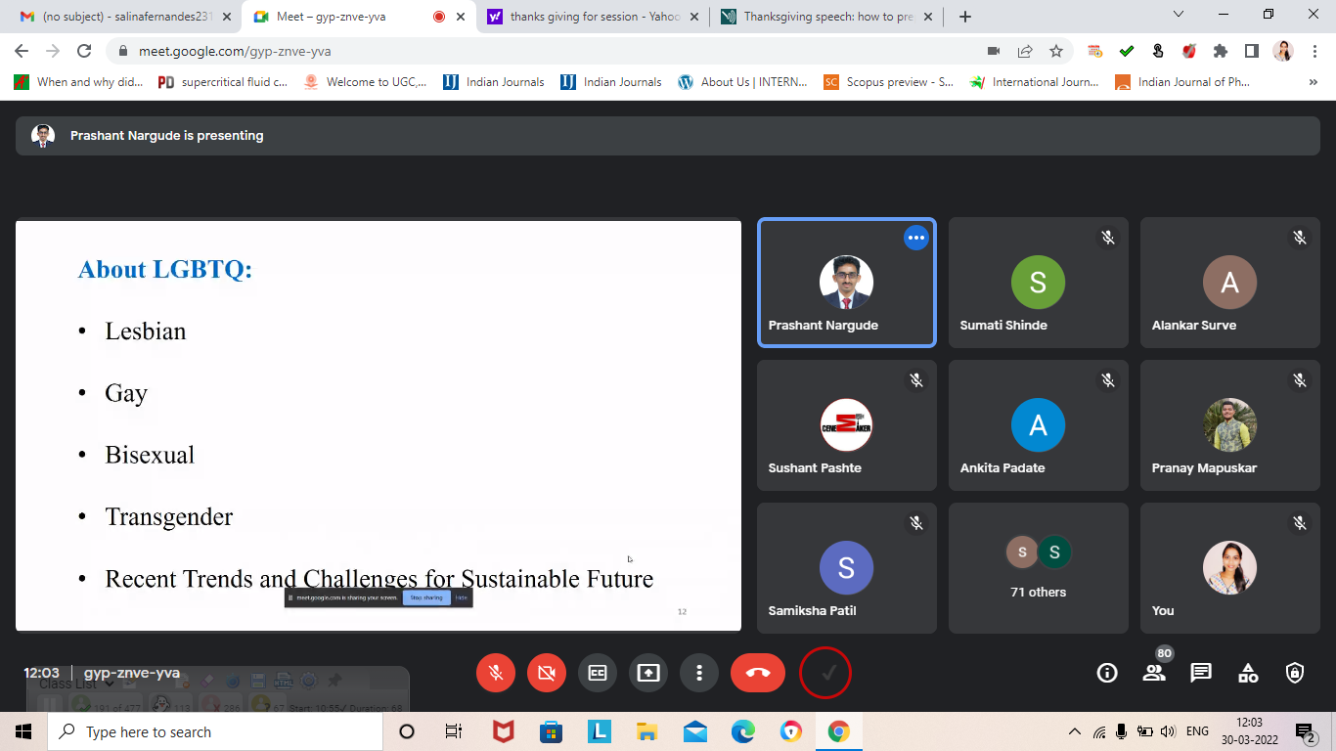
Event Photographs

