P S P S’s
INDIRA INSTITUTE OF PHARMACY
A Report on “Survey of adopted villages”
Date: March-April 2019

Unnat Bharat Unit of Indira Institute of Pharmacy has successfully adopted five villages (Poor, Patgoan, Ozare, Vighravali and Phansavale) situated in Sangameshwar area. UNNAT BHARAT ABHIYAN is programme launched by MHRD, Govt. of India for development of villages and to offer quality life to villagers. Indira Institute of Pharmacy has participated in the programme as participating institute. Under this programme, according to guidelines received from the IIT, Mumbai (Regional coordinating institute), the institute has conducted survey of adopted villages.
Aim of the survey:
To complete house to house survey of adopted villages and to collect required information.
Objectives:
- To identify potential problems at village.
- To identify the reasons behind the problems.
- To generate fruitful solution to overcome the identified problems.
Around 50 UBA volunteers as well as 10 faculties of the institute were actively engaged in collecting required information from each villager and collected the data by visiting more than 250 houses.
Following major information has been collected from villagers.
- No. of house owner and no. of family members.
- Govt. id proof of family members (Aadhar card/voter ID card).
- Source of income.
- Availability of fresh and clean drinking water.
- Availability of street light, milk collection centre and hospital.
- Potential problems in village.

Event Photographs

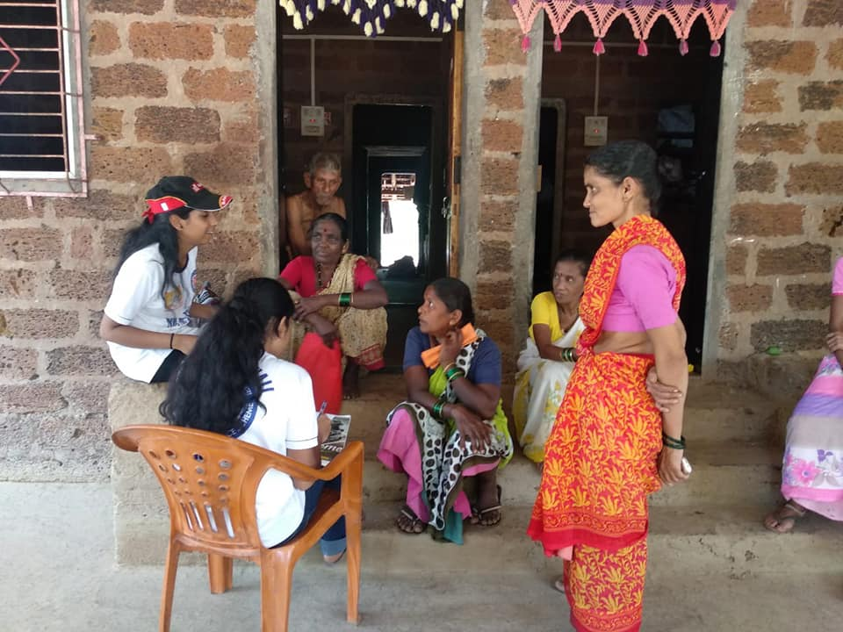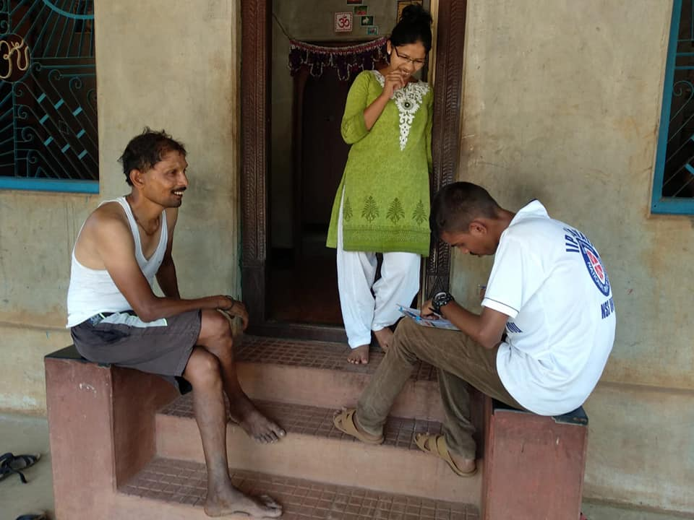
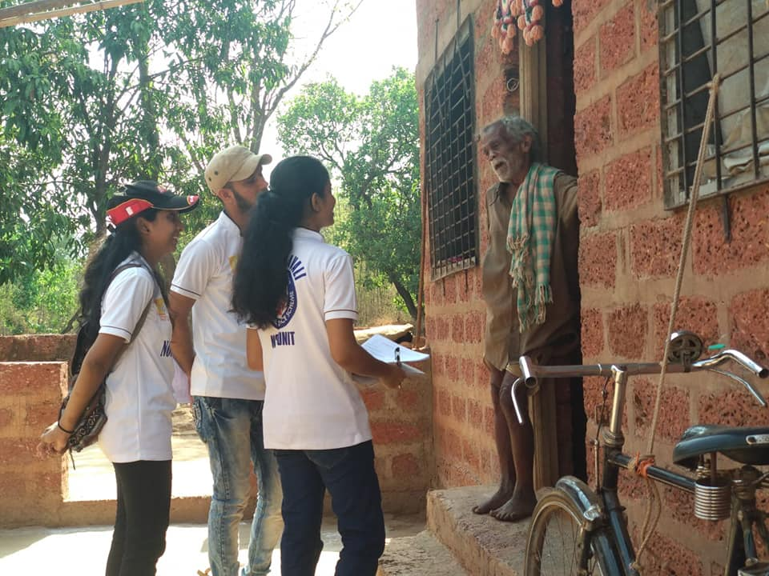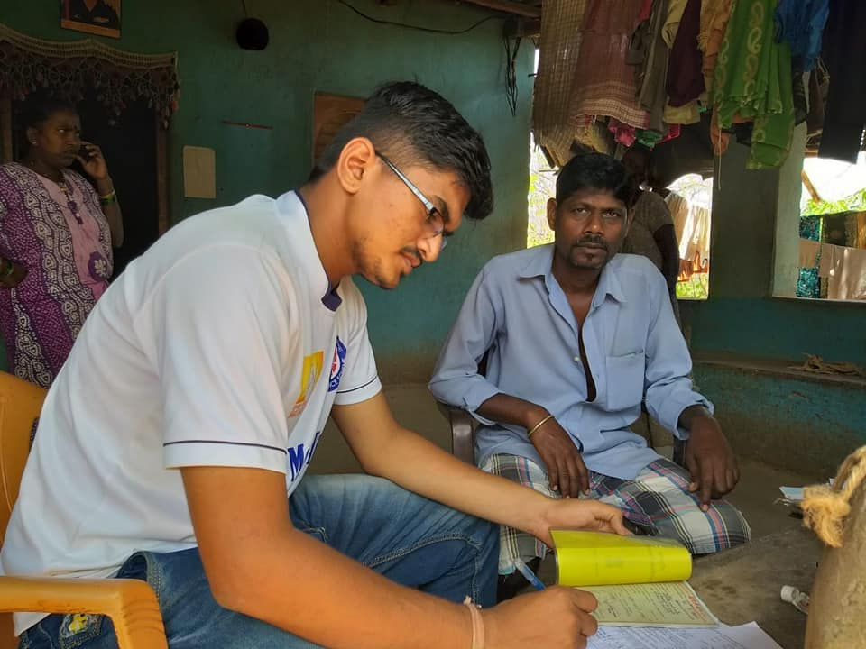

Supporting document

