P S P S’s
INDIRA INSTITUTE OF PHARMACY
A Report on “Covid 19 Awareness Campaign”
Date: 25/09/2020

NSS Unit of Indira Institute of Pharmacy, Sadavali organized HIV AIDS and Covid-19 Awareness Campaign in association with ICTC Department of Rural Hospital, Devrukh. The 50 NSS volunteers participated in activity and prepared awareness poster as well as videos. Both posters as well as videos highlighted important aspects like spread of virus, preventive measures and way of safety from infections. ICTC Department member, Ms. Vidya Mane guided volunteers to prepare posters and videos.
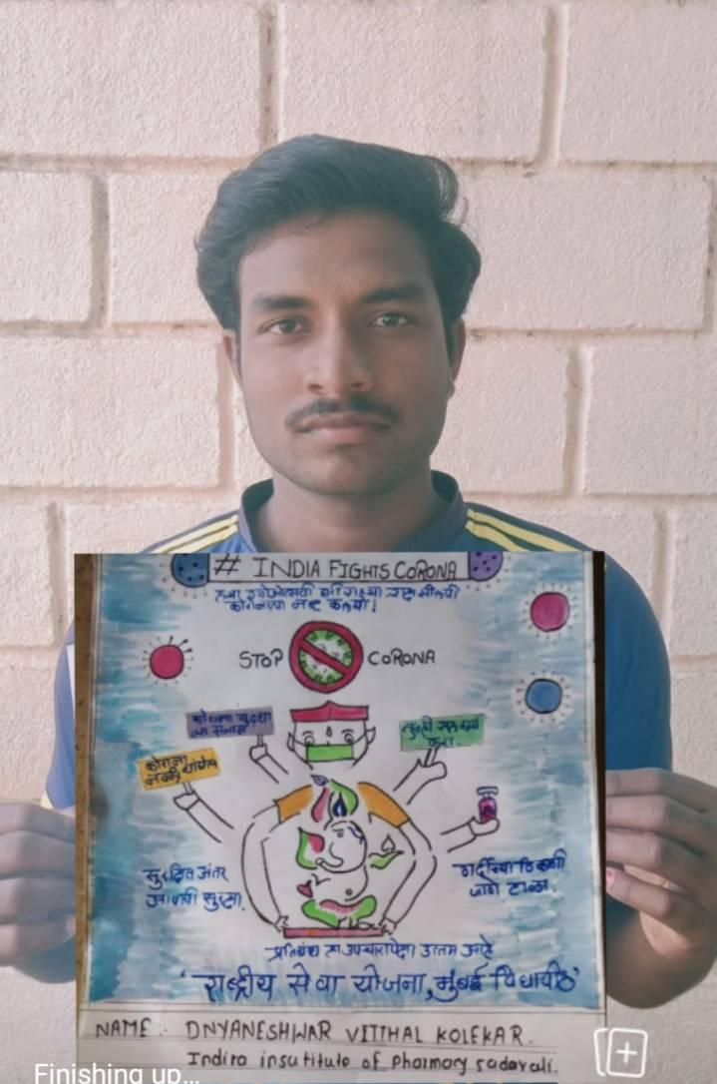

Event Photographs

