P S P S’s
INDIRA INSTITUTE OF PHARMACY
A Report on “HIV AIDS Awareness Campaign”
Date: 01/12/2020

NSS Unit of Indira Institute of Pharmacy, Sadavali organized HIV AIDS awareness campaign in association with ICTC Department of Rural Hospital, Devrukh. The programme was organized to create awareness about HIV AIDS in society through posters made by the NSS volunteers of IIP Sadavali. The Maharashtra State Aids Control Society guided to organized campaign under the heading of ‘selfie with slogan’. 50 NSS volunteers actively participated in activity and prepared posters.
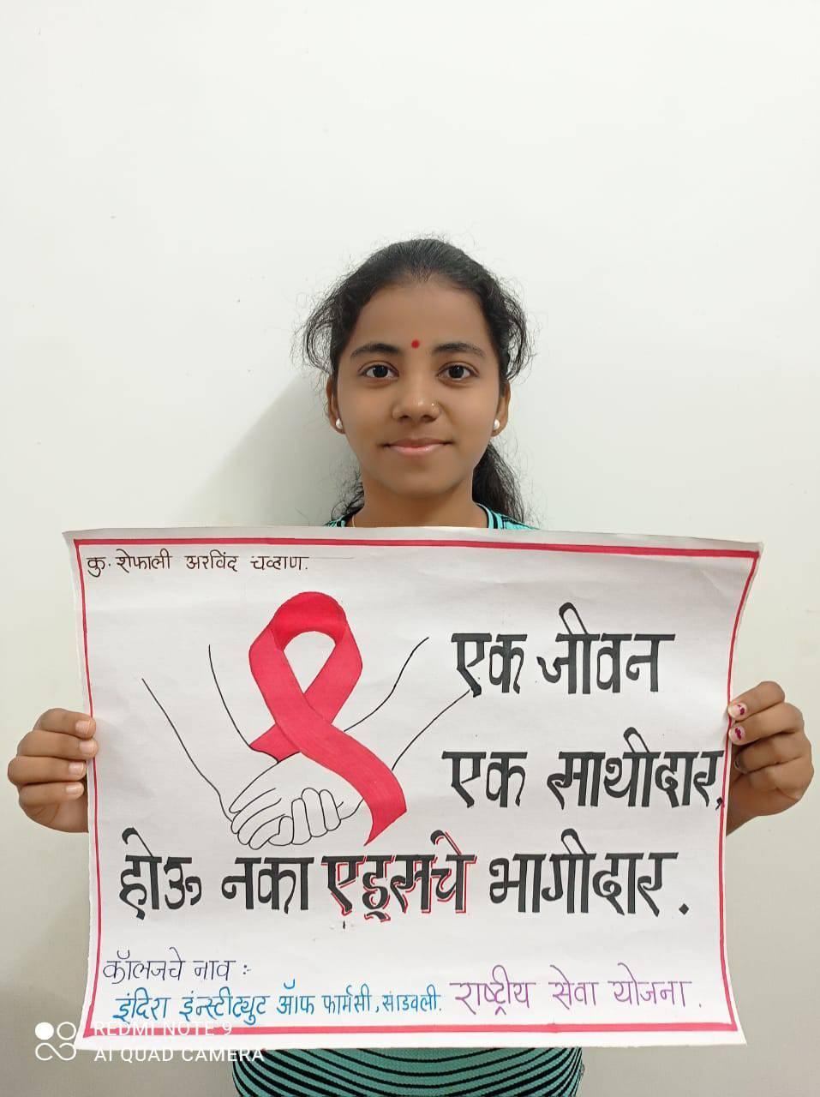
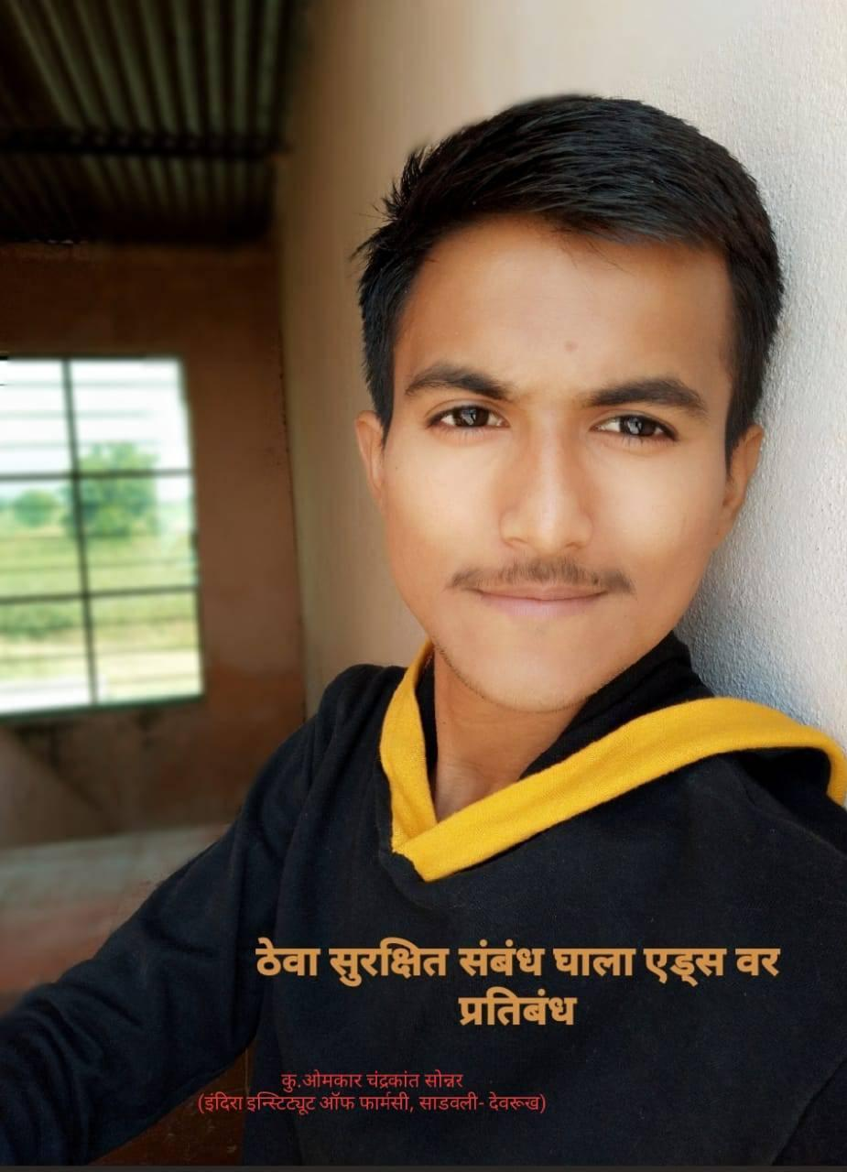
Event Photographs

