P S P S’s
INDIRA INSTITUTE OF PHARMACY
A Report on a “Impact Lecture Series” Session I
Date: 18/06/2022

IIP institute innovation council has successfully completed session 1 of the impact lecture series. The impact lecture series is sponsored by the ministry of eductions, AICTE, and the ministry of HRD’s IIC. The complete series was bifurcated into 2 sessions. The first session of the impact lecture series was conducted on 18/06/2022.
The Inauguration of the session was started with the formal introduction of the session by Convener IIC by Mr. Nikul Patel at 9:30 a.m. Further, the principal Dr. Amol B. Khade of the institute expresses the objective of the session. They concluded by expressing thanks to the MoE, AICTE, and IIC for providing the sponsorship for the impact lecture series.
The first session of the series comes with two different topics from two separate guest speakers. The first topic of the session was “Startup and Entrepreneurship opportunities in Healthcare.” The first lecture starts at 10:00 a.m. Ms. Anjori Parendekar (Mrs. Anjori Sachin Kumbhoje) was the resource person who deliver an excellent session on the above-mentioned topic. Ms. Anjori mam explains all modules for eneterprenerhip. During her session, she explores step by step process for any startup. Also, she makes aware participants during pandemic situations and how she can able to tackle new arising problems faced by any startup. She explains and evidences her talk with numerous case studies. At the end of the first lecture, participants' queries were resolved by Ms. Anjori mam. The gratitude towards the first eminent speaker was expressed by Mr. Sumeet M. Kharat (IIC President)
The second topic of the session was “The overview of the Indian patent with respect to global patenting system.” The second lecture starts at 11:30 a.m. Dr. Umesh Bankar was the resource person who deliver an excellent session on the above-mentioned topic. Dr. Umesh explains both Indian as good ass global patenting systems separately. Further, he correlates both the system very well which brings more attention to the participants. Then, he proceeds with some simulating presentation, which clears all the process of patenting. Detailed exposure to the global patenting system clears the process for the audience. At the end of the second lecture, participants' queries were resolved by Dr. Umesh Bankar. The gratitude towards the second eminent speaker was expressed by Mr. Sumeet M. Kharat (IIC President)
During the session, Ms. Sanika Narvankar introduce the first eminent speaker, while Ms. Gauri Thatte introduces the second eminent speaker. Finally, the whole session was concluded with a vote of thanks by Ms. Akshata Jadhav.
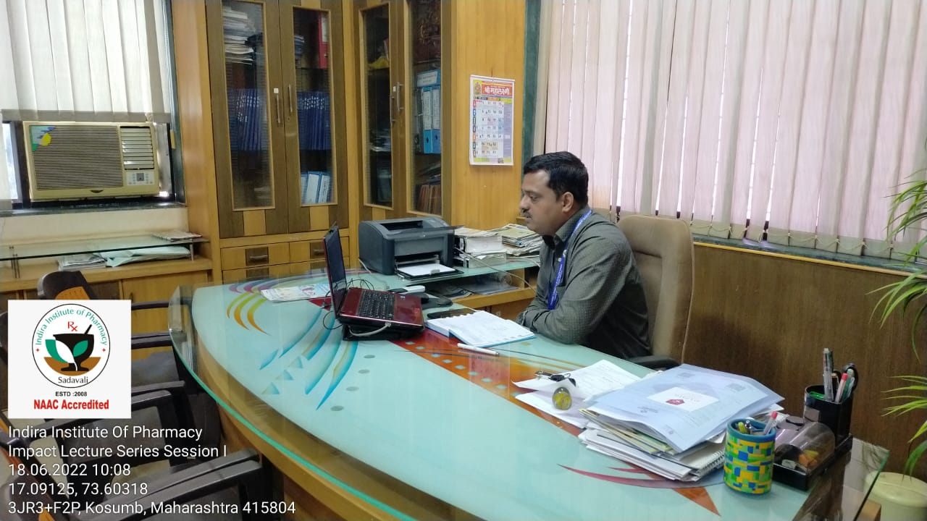
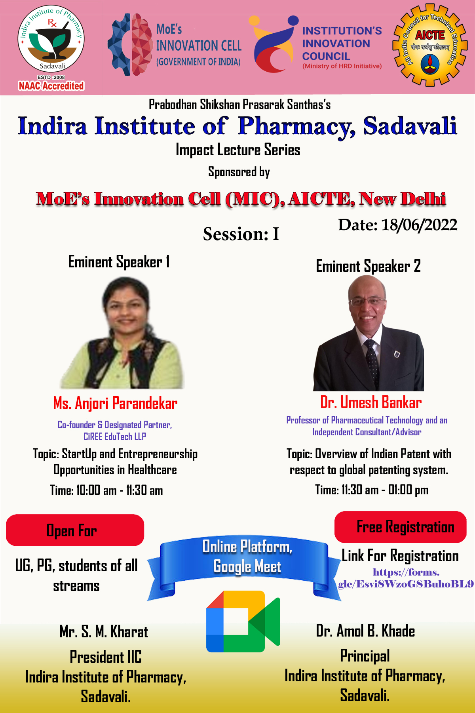
Event Flyer

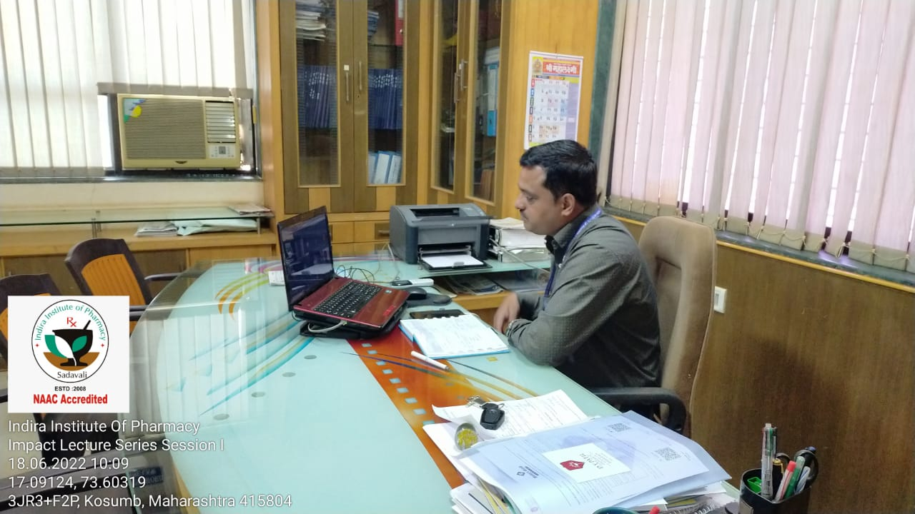
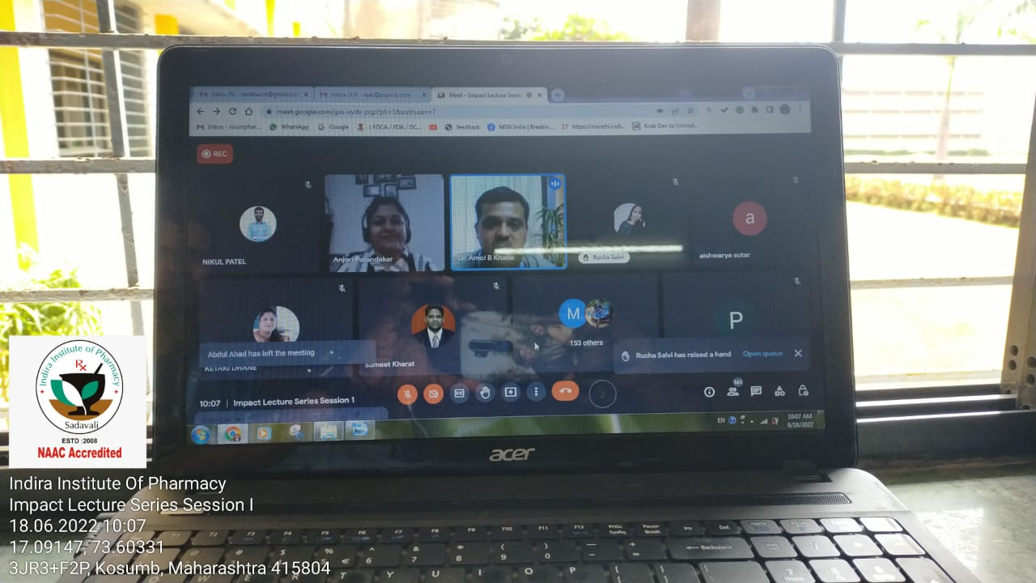
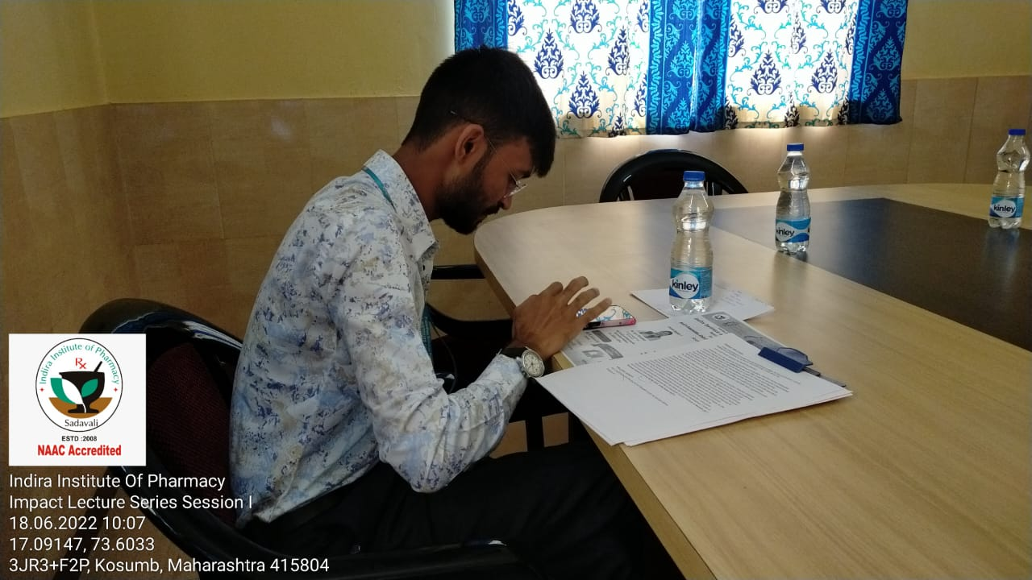
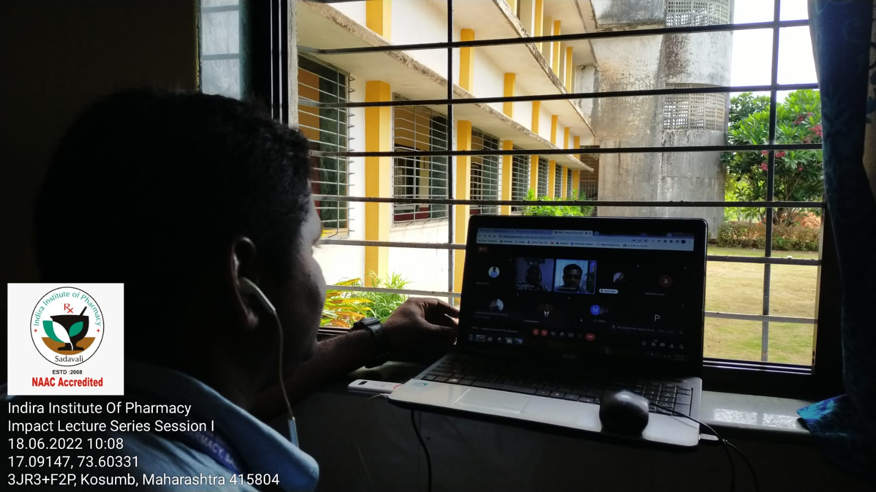
Event Evidence from Participants
Event Photographs

